RL24 Owners Association |  | 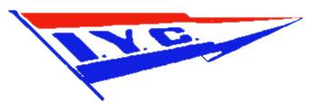  ILLAWARRA YACHT CLUB
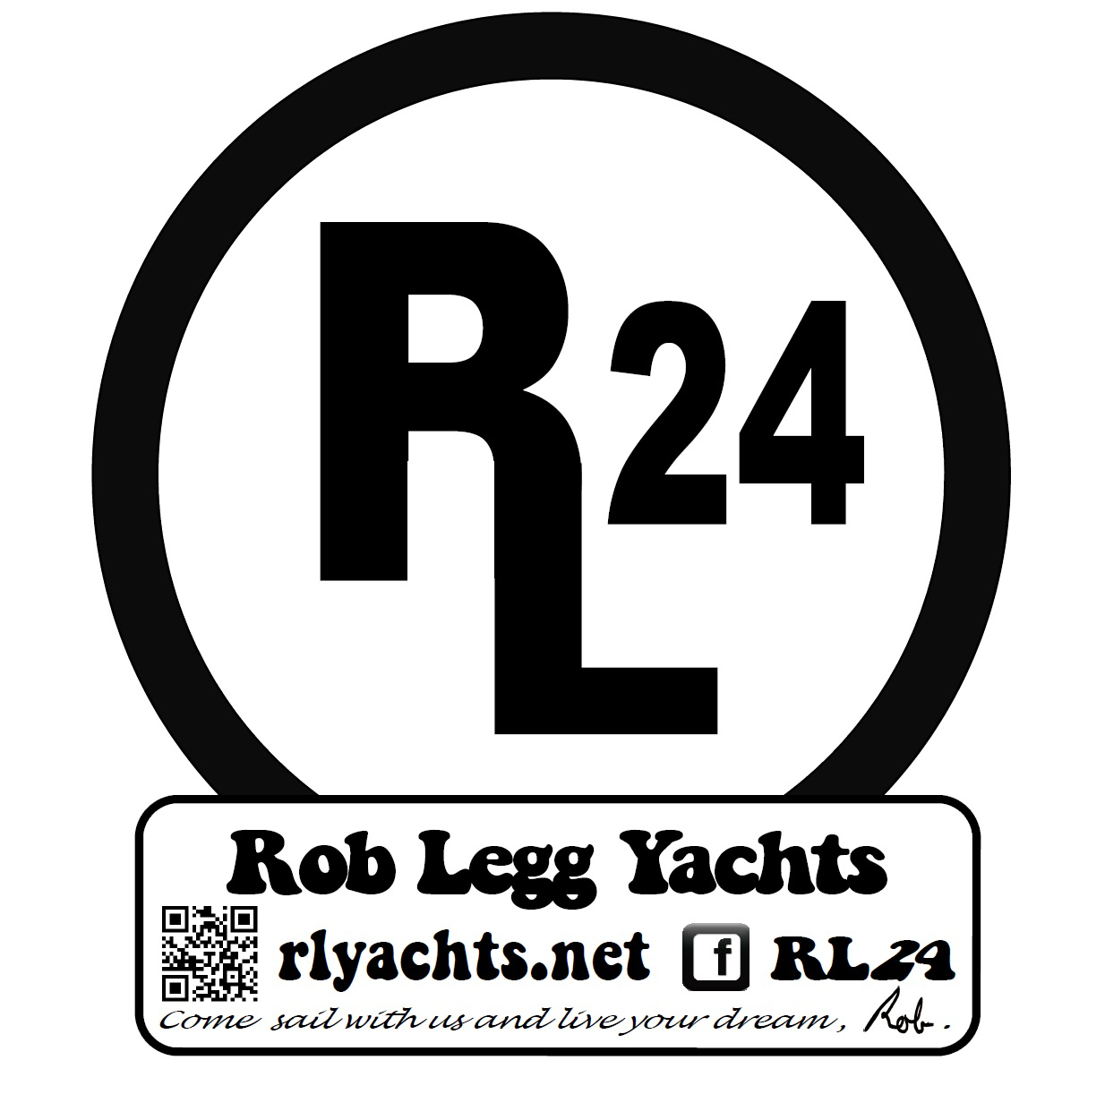

NOTICE OF RACE

2019 - 2020 RL24 NSW STATE TITLE CHAMPIONSHIPS

Heat 1 16th November 2019
Heat 2 16th November 2019
Heat 3 17th November 2019
Heats 1, 2 & 3 at ILLAWARRA YACHT CLUB.
Located at 1 Northcliffe Drive, Warrawong.
1. Rules and Organising Authority.
The NSW RL24 State Title Championship is organised in conjunction with the Illawarra Yacht Club and will be governed by the Racing Rules of Sailing (RRS) for 2017-2020, the prescriptions and Special Regulations of Australian Sailing 2017-2020 Part 1 for Racing Boats, the RL24 Class Constitution and Class Rules and by the Sailing Instructions. This is a Category 7 event. In the event of any discrepancy the provisions of the Sailing Instructions shall take precedence.

  - RRS 32.1 will be changed “As an alternative to shortening the course using Race Signal “S”, the following alteration can also apply: Race Signal ‘S’ over ‘H’ when displayed on or near a mark means the race is shortened. Boats shall, after rounding or passing the mark and completing the course of the leading boat, proceed directly to the finish line.”

2. Eligibility and Entry.
The NSW RL24 State Championship is open to all RL24 Class Trailable Yachts that are registered with the RL24 Owner’s Association of Australia and who are financial members of the RL24 Owner’s Association of Australia for the 2019-2020 season. Eligible boats may enter the regatta on the attached entry form and accompanied by the required fee. Beach entries will be accepted on Saturday 16th November from 11:00 – 12:00. Entrants shall carry $10M minimum indemnity insurance.

3. Fees
The Entry fee for the NSW RL24 State Championship is $45-00. This entry fee must be paid before Heat 1 of the State Championships.

4. Schedule of Events.
Events are scheduled for the NSW RL24 State Title Championships as follows:
Registration will be held in the IYC Lake View Room from 1100 – 1200 hours Saturday 16th November 2019.
Heat 1 - Warning Signal time not before 1330 hours Saturday 16th November 2019.
Heat 2 - Warning Signal time not less than 5 minutes after last boat in Heat 1 on Saturday 16th November 2019 has finished.
Heat 3 - Warning Signal time not before 1100 hours Sunday 17th November 2019.

5. Measurements and Safety
Entrants will be expected to meet the measurement requirements as specified by the RL24 Owner’s Association of Australia.

6. Sailing Instructions.
The Sailing Instructions for the NSW RL24 State Title Championships will be available from IYC race headquarters from 1100 hours Saturday 16th November 2019 after registration has been completed.

7. Racing Area and Courses.
Heats 1, 2, & 3 will be conducted on Lake Illawarra as illustrated on courses as described in the Sailing Instructions.

8. Scoring.
The Low Point scoring system, Appendix A4.1 will apply except that except that first place in each race will score 0.75 point. Three (3) races constitute the NSW RL24 State Titles series. A minimum of 1 race is required to make up the NSW RL24 State Title Championship event. Each boat’s score will be the total of her three race scores. All scores shall be counted. Where there are insufficient starters for separate Swing Keel and Drop Keel Division, all RL24s will sail together and elapsed times will be corrected using Australia Sailing’s ATYSB’s Class Based Handicaps (i.e. DK = 0.760; SK = 0.725).

9. Prizes.
For the NSW RL24 State Title Championships, prizes will be awarded for 1st, 2nd and 3rd placings on CBH corrected elapsed times. Overall placings and prizes for the NSW RL24 State Title Championships will be presented at the conclusion of Heat 3 at the Illawarra Yacht Club house.

10. Facilities.
Illawarra Yacht Club welcomes entrants to use their facilities.
Boat launching facilities are available at Illawarra Yacht Club’s site and at Port Kembla Sailing Club (Berkeley).

11. Radio Communication

Except in an emergency while racing, a boat shall neither make nor receive data, voice or radio transmissions which are not available to all boats. This restriction also applies to mobile telephones.

12. Safety

The Safety Category applicable to this series is Australian Sailing Special Regulations Section 2.01.8 Category 7. In addition the following shall apply.
- 3.24.3(b) Outboard motors shall be mounted in the normal operating positions at all times but may be retracted while sailing. A minimum of 9 litres of fuel must be carried at the start of each race.
- Life jackets or Personal Flotation Devices (PDF) shall be worn by all crew members at all times while afloat during the NSW RL24 State Title Championships.

13. Disclaimer of Liability.

Competitors participate in the regatta entirely at their own risk. See RRS 2017-2020 Part 1 Rule 4, “Decision to Race”. It is the Competitor's decision to enter the Regatta or to start or continue in any race. Neither RL24 Owners Association of Australia nor the Illawarra Yacht Club will accept any liability for material damage or personal injury or death sustained in conjunction with or prior to, during, or after the regatta.

14. Risk Warning.

This RISK WARNING is issued jointly by the Illawarra Yacht Club and the NSW Maritime Authority, pursuant to the Civil Liability Act 2002 to all persons wishing to participate in the sailing activities conducted by Illawarra Yacht Club.

Participants are warned that, regardless of the precautions, which might be taken by reasonable and experienced persons, sailing can be a dangerous pursuit and participants are exposed to significant risk of property damage, physical harm and possibly death.

As an indication, these risks may include, but are not limited to:

- The extremes of weather and sea conditions.
- The potential that control of vessels may be lost, resulting in collision with objects and other vessels.
- The sudden movement of the vessel at any time and the possibility that participants may fall or be thrown overboard, resulting in drowning.
- The possibility that participants may be injured by equipment on the vessel.
- The absence of immediate medical care and the likelihood that significant delays may occur before medical care is available.
- Exposure to the elements for extended periods.

Illawarra Yacht Club and the NSW Maritime Authority also warn participants that regardless of their best intentions, they may be unable to render assistance to participants who are in distress. Participants are warned to consider the above risks and all other risks before deciding to participate in any sailing event with Illawarra Yacht Club.

Participants are also advised that although Illawarra Yacht Club is covered by third party liability insurance, this cover DOES NOT extend to participants. Any participant who considers they have a need for insurance must make their own private arrangements with an insurer. A personal accident insurance policy is available with subscription to membership of Yachting NSW.

Further Information:
Please contact –: Colin Boylan 0427 273084 or boylan.colin@gmail.com

RL24 NSW STATE TITLE CHAMPIONSHIP
2019 – 2020 NSW RL24 STATE TITLE CHAMPIONSHIPS
ENTRY FORM
Entry Fee: $45 – 00
Owner’s Name: .........................................................................................................................
Owner’s Address: ………………………………………………………………………...
…………………………………………………………….... Post Code ………………...
Owner’s Phone (H): ......................................... (Mobile) ......................................................
E-Mail (if available): ................................................................................................................
Skipper’s Name: .......................................................................................................................
Boat Name: .............................................................................. Sail Number: .......................
Boat Type: Swing Keel Drop Keel (Circle one)
Australian Sailing National membership Number: ………………………………………..
DECLARATIONS
My boat complies with the RL24 Class Owners Association of Australia rules and specifications. YES / NO ( delete one).
Details of modification: _____________________________________________________
My boat complies to the mandatory safety requirements of 2017-2020 Racing Rules of Sailing, Australian Sailing Special Regulations Part 1 2017-2020 Section 2.01.8 Category 7 and the RL24 class rules. YES / NO ( delete one).
My boat or its skipper carries a minimum of $10 million or more third party liability insurance. This insurance will remain in force for each and every race sailed in the series.
I agree to the Indemnity Declaration for the NSW RL24 State Title Championships and for the Sailing Competitors at Illawarra Yacht Club.

I agree to be bound by the Racing Rules of Sailing and all other rules that govern the event
Signed:_______________________________________________ Date:_____________
Witness:_______________________(name)___________________________(signature)

Please complete and email your entry form to:
Colin Boylan at Boylan.colin@gmail.com before 16th November 2019.
Forms will also be available at IYC’s Registration Centre.

Notice of Race IYC INDEMNITY Declaration.
Indemnity Declaration for Regatta Competitors at Illawarra Yacht Club for Boat/Number: __________________________
I, in my capacity as the Adult entrant, Parent, Legal Guardian or Custodian of the Skipper/Crew of the boat referred to in the Entry Form:
1. acknowledge that this entry is made subject to the conditions set out in the Notice of Race and Sailing Instructions as may be amended by the Organising Authority.
2. acknowledge that all racing conducted by the Organising Authority will be governed by the rules and regulations specified in the Notice of Race and Sailing Instructions, as they may be amended.
3. warrant to the Organising Authority that:
a. I have read and understand the Notice of Race and Sailing Instructions and that, if they are amended by the Organising Authority, I will read any amendment.
b. I have provided a copy of and brought the Notice of Race and Sailing Instructions to the attention of the crew of the boat (if any) and have satisfied myself that the crew of the boat (if any) understand the Notice of Race and Sailing Instructions.
c. I will provide a copy of and bring any amendment to the Notice of Race and Sailing Instructions to the attention of the crew of the boat (if any) and will satisfy myself that the crew of the boat (if any) understand any amendment.
d. the boat referred to in the Entry Form:
(i) is and has been properly maintained; and
(ii) is structurally sound and seaworthy (including hull, spars, rigging sails and all gear);
(iii) is suitable for the event or events referred to in the Entry Form;
(iv) carries all necessary and required equipment (including emergency equipment).
e. I and the crew of the boat (if any) will, while participating in the event or events referred to in the Entry Form, comply with the rules of this declaration.
f. I and the crew of the boat (if any) are aware of ISAF Fundamental Rule 4 “Decision to Race” which states “The responsibility for a boat’s decision to participate in a race or to continue racing is hers alone”.
g. I and the crew of the boat (if any) are all individually aware of and conversant with the risks involved in the sport of sail boat racing.
h. I and the crew of the boat (if any) are all individually aware that the participation in a race is entirely at our own exclusive risk and that the Organising Authority excludes all liability in the manner referred to in the Notice of Race.
i. I and the crew of the boat (if any) acknowledge and accept the risks associated with participating in the event or events referred to in the Entry Form including:
(i) any risks referred to the Notice of Race; and
(ii) the seaworthiness or otherwise of any boat participating in the event or events
(iii) the participation, including negligent participation, by persons in the event or
(iv) the defaults, acts and omissions of persons, including negligent defaults, acts referred to in the Entry Form; events referred to in the Entry Form; and omissions of the Organising Authority and its officers, employees and agents and the crews of other participating boats.
j. I and the crew of the boat (if any) acknowledge and accept that the Organising Authority:
(i) does not and cannot control, diminish or affect the perils of the sea;
(ii) is not in a position to take precautions against the risk of harm to persons
(iii) may not be in a position to provide advice, assistance or support to boats and
k. I and the crew of the boat (if any) release, hold harmless and indemnify the Organising Authority and its officers, employees and agents from all liability any of those persons has to the owner/skipper or any crew member on the boat, or to any person claiming through or under any such person, arising from the loss of life or injury to persons, or loss of or damage to property, howsoever caused, including by negligent act omission, arising out of or relating to:
(i) participation by the boat or any other boat in the event or events referred to in
(ii) the conduct or courses of races in any respect including any act or omission arising from the perils of the sea; and crews during the course of the event or events referred to in the Entry Form; and/or (whether reasonably foreseeable or not) causing or relating to loss of or damage to any boat or the death of or injury to any person.
l. I and the crew of the boat (if any) indemnify the Organising Authority and any officer, employee or agent in respect of any costs in respect of any assistance that may have to be rendered to the boat or crew (if any) in respect of any rescue including if the boat becomes disabled or any person is overboard or for any other reason.
m. I and the crew of the boat (if any) acknowledge and agree that the contract formed by the acceptance of the Entry Form by the Organising Authority is governed by the law of New South Wales.
4. declare that the information in the Entry Form is correct .

(PRINT NAME) _____________________________________ (SIGN) ________________________Date:______________
NOTE: Parent, Legal Guardian or Custodian to also sign for all entrants under the age of 18.
I,____________________________________ Of (ADDRESS) _________________________________________________
being the parent, legal guardian or custodian of (Entrant under 18) _______________________________________________
Consent to him/her/them participating in this regatta and indemnify the Organising Authority.
Signed:_____________________________________________ (Parent, Legal Guardian or Custodian) Date:______________.

